**Jaypee University of Engineering & Technology, Guna**

Department of Computer Science and Engineering

18B11CI312 – Database Systems

Assignment 1

Submit the assignment at 5PM on 30th Nov 2023 at my office

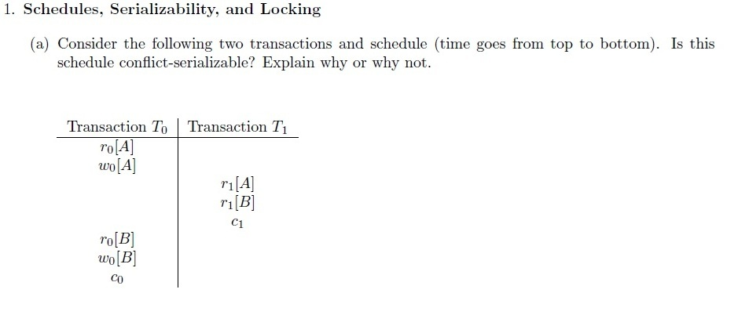

Why is locking used?